For Release
September 19, 2019

Retra-Tablos is funded by The Ellies, Miami’s visual arts awards, presented by Oolite Arts and the Coral Gables Museum. Recipients Aurora Molina and Alina Rodriguez, 2018 Creator Awards.

Retra‐Tablos
Reclaiming culture, Ancient Textile Art
& Children of Immigration (Los Niños de Inmigración)

Coral Gables— September 16, 2019— The Ellies, Miami’s visual arts awards, Oolite Arts and the Coral Gables Museum is presenting Retra-Tablos: Reclaiming Culture and Ancient Textile Art, on view from November 1st to November 17, 2019 at the Coral Gables Museum. A grand opening with interactive presentations on backstrap weaving on Friday, November 1, 2019 from 6 to 8 pm is open to the public with a short free lecture and related presentation from 5 to 6 pm. Among other amenities in the courtyard, there will be live music in collaboration with the University of Miami’s Frost School of Music, a cash bar and light bites. This event is brought to you on the first Friday of every month, in conjunction with Coral Gables Gallery Night. FREE ADMISSION!
Join us for Family Day on Saturday, November 9, 2019, 2-5 pm, learn about backstrap weaving textile arts of Guatemala, create paper embroidery, make simple weavings, be creative using Mayan patterns on coloring book pages to make a self-portrait, free fun art activities for the family, live marimba musical performances and more! FREE ADMISSION!
Every autobiographical artwork (retrato) in this show narrates an immigrant child’s story embedded in their Mayan ancestry, legend, folklore and their assimilation as a recent migrant or as a child of immigrant parents. The portraits mix Mayan deities, symbols, Catholic iconography, and American pop culture. The works by the sixteen artists ages 6 to 12 borrow from the Catholic Spanish “retablos” tradition. A retablo is a framed votive painting usually meaning behind the altar. Indigenous colonized and converted people adopted the iconography turning the retablos into bright, vibrant folk art of their own.
Backstrap woven and embroidered replicas of the young artist’s drawings bring further voice to the children and the artisans from Trama Textiles, Guatemala who illuminated these contemporary expressions using textiles and thread.
“Te felicitamos Aurorita y Alina por este trabajo tan especial y por los bellos retratos que los niños crearon en papel y que ahora disfrutan en bordado. Estamos orgullosas de este proyecto establecido con tanto sentimiento y gran profundidad. “We congratulate you Aurorita and Alina for such special work and for the beautiful self-portraits created by the children on paper which they now enjoy as embroideries too. We are proud of this project conceived with such depth and sensitivity.” Amparo de Leon De Rubio y Oralia Chopen, and artisans Brenda Josefina Velazquez, Ingrid Maria Velazquez from Trama Textile, Maya Women’s Cooperative, Xela, Guatemala.”
The exhibit is the product of a year-long arts-in education program spearheaded by Ellies recipient artists Aurora Molina and Alina Rodriguez working with immigrant children from the Guatemalan-Maya Center in Lake Worth, Florida in coordination with the school director Xiomara Guerra. Father Frank O’Loughlin, a Catholic priest is the co-founder of the Guatemalan-Maya Center in Lake Worth and its after school care which assists children and parents by providing free extra after school assistance and a safe place for children while their parents work. Americans for Immigrants Justice (AIJ) honored Father Frank this February 2019 for his human rights legacy as a migrant champion for more than 50 years.
Policarpia Gaspar, co-founder of the center was a Guatemalan civil war exile who devoted her life to helping refugee children and families. Mrs. Gaspar passed on this May 2019 after a lifetime of social work. The Retra-Tablos exhibition honors her memory by collecting and documenting the cultural narratives of Mayan children and highlighting the textile arts and huipiles of Guatemala that she proudly wore throughout her life.
The Retra-Tablos exhibition not only aims to reclaim history, memory, culture and bring

value to ancient textile arts- it wants to place (los niños de inmigración) the children of

immigration front and center and give them a voice. To this purpose, Aurora Molina aligns with

Americans for Immigrant Justice and gallerist Bernice Steinbaum in also exhibiting a large quilt

in process titled Sew America (So America Cares): Immigration Quilt. The quilt raises

awareness on the current state of immigration and shines a light on the increase of child death,

deportation and detention. Each appliqued panel by artists, teachers, children and adults

is rendered in textiles and feature the silhouetted face of a migrant departed child. The quilt will

continue to grow as more artists and individuals contribute to making more panels.

In addition, Sharon Smith, composer with La Chance Music has produced a musical score with a video production by Director Fina Torres and Producer Esther Levin with Jacaranda Produciones exclusively to complement the show. The project documentation video is produced by Damian Rojo.

For more information, press only:
For Additional Information:
Aurora Molina, Phone number: 786-337-0920
info@auroramolina.com
www.auroramolina.com
Alina Rodriguez, Phone number: 305-300 6887
Email: alinarodriguezrojo@gmail.com/

About the Coral Gables Museum: The exhibition, Coral Gables’ Sister Cities: Partners in Peace, is dedicated to the City of Coral Gables’ beloved sister cities and the sister cities movement launched by President Dwight D. Eisenhower in 1956. Visitors are invited to learn about the history of this international peace program and uncover the connections between Coral Gables and her sister cities: Aix-en-Provence, France; Cartagena, Colombia; Granada, Spain; La Antigua, Guatemala; and Pavia, Italy. Images and text tell the story of our nation in a Cold War environment and how Eisenhower, with his extensive wartime experience and leadership abilities, rallied the public to reach out to citizens of other nations in an effort to promote cultural understanding and world peace. “I hate war”, he said, “as only a soldier who has lived it can, only as one who has seen its brutality, its stupidity.” Each of the five sister cities will be represented through photographs, objects, explanatory text, videos, books, maps, and other media. A research library will be available for those visitors interested in learning more about a particular sister city.
Ongoing in the Perrin International Reception Hall
About Oolite Arts
Three decades ago, our founder, potter Ellie Schneiderman, sought affordable work spaces for our city’s visual artists. Today, Oolite Arts continues Schneiderman’s mission, to, as she said, “help artists help themselves.” We are both a community and a resource, providing artists with the free studio space, exhibition opportunities, direct support and programming they need to advance their careers. We also offer programming to the surrounding neighborhood and the wider community to help them better understand, and create, contemporary art.
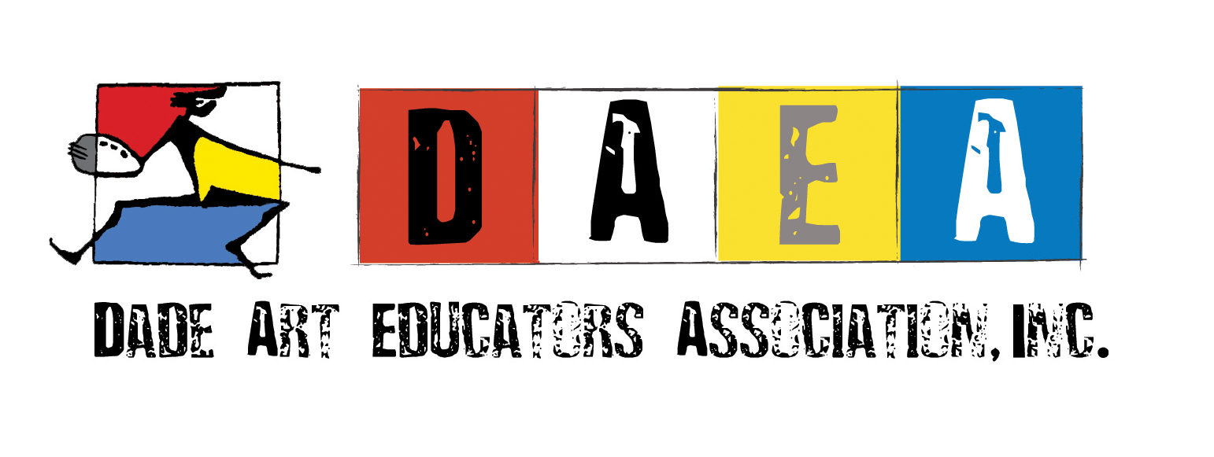
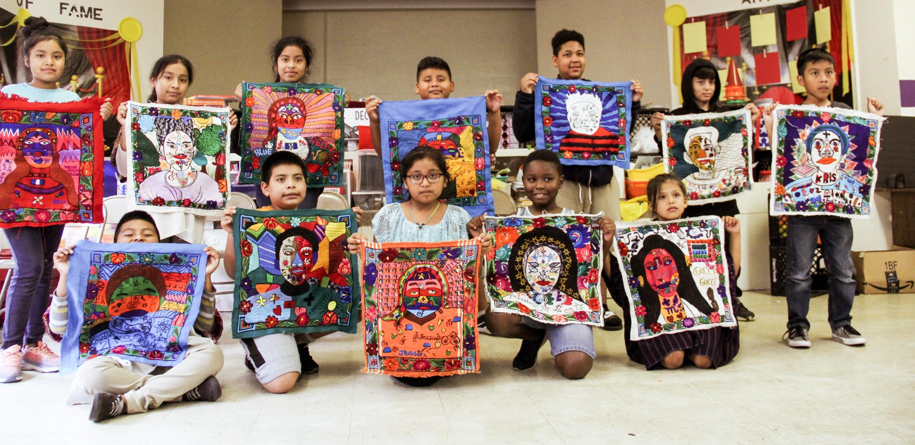 Students holding their weavings made by the Guatemalan artisan from their original drawings.

